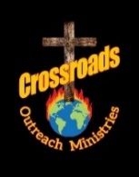
NOVEMBER 2025 UPDATE
www.crossroadsoutreachministries.org

Friends and Partners-
Exciting things have been happening since we have been sent out by our home church Shiloh Christian Ministries. As we were “refired” anointed and sent out in this new season, I wanted to highlight some of the things that we have been privileged to be a part of in 2025.
“Prayer, Presence and Purpose” has become a resounding theme about what God has called us to do during this season. Forever and foremost in our heart and ministry is “souls for the Kingdom of God.” This we do locally, nationally and internationally. Crossroads is not just a “missions” ministry but, an evangelistic outreach spanning the globe and following the “Call of God.” We always say in our heart, “Here I am, send me.” In all of this God has faithfully directed our steps.
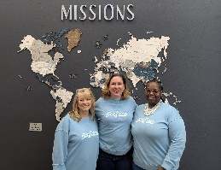
In December of 2024, Crossroads partnered with Shiloh Christian Ministries and travelled to Living Water Teaching in Guatemala. There 4,439 shoeboxes were distributed, the gospel was presented as 2,144 children and adults received the Lord in their lives. This year once again a team with Crossroads and Shiloh are travelling to Living Water Teaching in November. We will expect to hear of the faithfulness of God as we will receive reports of the salvations, healings, victories and blessing in the lives of those who are touched this year! To God be all the praise and glory!
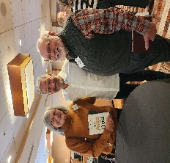
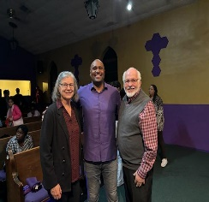
In January 2025 we attended a special Pastor’s and Leaders Seminar with John Bevere sponsored by Bridgebuilders of Arizona and ”Start the Year off Right” in Tucson, Az. We also ministered with Apostle Jamie Benjamin at Tucson’s “Global Intercessors Gathering” at Greater Faith Church for a weekend of strategic intercessory prayer, teaching, impartation and activation. This was a powerful time in the presence of the Lord!
We are thankful to God for His faithfulness and His hand that has been extended to others! We have witnessed salvations, healings, freedom and His purposes being established everywhere we go. Your partnership with us is cherished and invaluable!
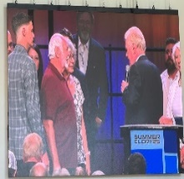
We were privileged to participant in “Summer Glory” with Pastor John Kilpatrick in Daphne, Alabama where Dr. Tim Hill ministered powerfully and we received a word of impartation and direction as we carry out the “Call and Mandate of Crossroads Outreach Ministries .”
We have conducted many funerals, weddings, counseling sessions, ministry consulting and ministered at weekend encounters and minister everywhere we have gone as we’ve walked out 2025. In additional we have provided financial support for Mexico, Belize, Guatemala, Teen Challenge and many other worthwhile endeavors. And we will continue to support and go where God will send us, as He is directing in 2026! We cannot do this alone or without your partnership. Will you prayerfully consider partnering and believe with us with your prayers and finances?
If you wish to partner with us financially, you can use the QR code below to do so. Your prayers and financial support are valued, welcomed and appreciated! May God continue to bless and guide you in all that you do!
In Pursuit of Him,

Atticus L. Register, Jr
Dr’s Atticus & Marge Register

